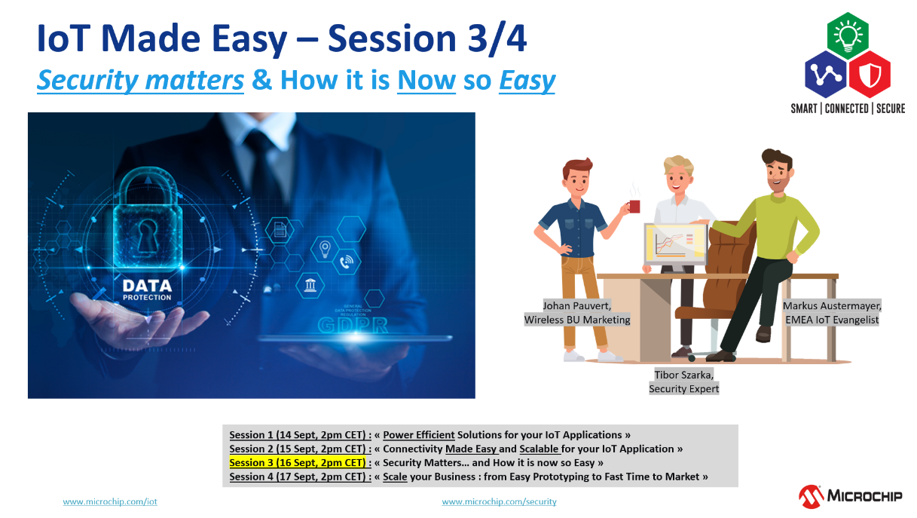

|  |  |  |  |  |  |  |  |  |
| --- | --- | --- | --- | --- | --- | --- | --- | --- |
| |  | | --- | | Meeting number (access code): 145 406 8543 | | Meeting password: cTsyv6kvx62 |  |  |  | | --- | --- | | |  | | --- | | [Подключиться](https://microchip.webex.com/microchip/j.php?MTID=mcf029b2969a12cb60d513d169cd76640) | |  |  | | --- | | **Tap to join from a mobile device (attendees only)**   [+1-415-655-0001,,1454068543##](tel:%2B1-415-655-0001,,*01*1454068543%23%23*01*) US Toll   [1-844-621-3956,,1454068543##](tel:1-844-621-3956,,*01*1454068543%23%23*01*) United States Toll Free   **Join by phone**   +1-415-655-0001 US Toll   1-844-621-3956 United States Toll Free   [Global call-in numbers](https://microchip.webex.com/microchip/globalcallin.php?MTID=mac0c517ba40304d507b7c8250bb44e01)  |  [Toll-free calling restrictions](https://www.webex.com/pdf/tollfree_restrictions.pdf)    **Join from a video system or application** Dial [1454068543@microchip.webex.com](sip:1454068543@microchip.webex.com)   You can also dial 173.243.2.68 and enter your meeting number.    **Join using Microsoft Lync or Microsoft Skype for Business** | | Dial [1454068543.microchip@lync.webex.com](sip:1454068543.microchip@lync.webex.com) | | Need help? Go to <http://help.webex.com> | | |